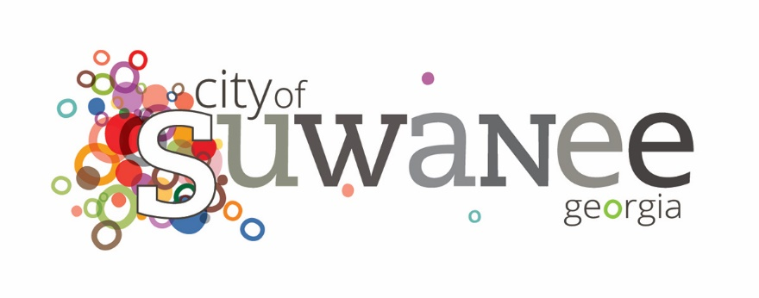

Event Marketing Package

Thank you for choosing the City of Suwanee as the location for your event. We are honored to partner with you to ensure that you, the event planner and your guests have a fantastic experience. Event marketing is a critical component to getting out YOUR message! Part of your event planning with the City of Suwanee includes event marketing to help promote event participation and attendance. The following is a brief synopsis of what this includes.

Marketing Package
At a minimum, event promotions include:
- Standalone event logo post on Facebook and Instagram, with accompanying promotional copy and registration links (if applicable). We are happy to include previous years’ photos as well (pending city approval) to help boost the attractiveness of the post.
- A singular “This Weekend in Suwanee” post on Facebook and Instagram, typically on the Wednesday before the event date.
- Event listing on the event page on Suwanee.com.
- Connection to your Facebook event listing to show up on the City of Suwanee’s Facebook account.
- Feature on our annual event postcard, which is distributed to all 30024 addresses.
- City-produced annual event posters, which are on display at City Hall and local business partners.

Additional Advertising
If time and/or space permits, we may provide additional advertising. These could include the following:
- Slider on the main page of the Suwanee.com website.
- One or two banners within the city (produced by you and delivered to city hall).
- Print advertising in the Gwinnett Daily Post, Suwanee Magazine and/or The DiG.

